Solution for ”Front End Software Engineer” Evaluation
Author: Lang Xie
Email: lang.xie@gmail.com
Mobile: 97608496

Define Project

Project Overview
Implement a program which satisfies the following requirements:
- Present a big text input area in which a reasonably large text can be written or pasted.
- Present a slider control or similar which can be used to control the aspect of the grid described below.
- Present a grid or table with horizontal cell count (width) and height determined by the slider value. The cells should contain the words from the text laid out from the top left corner, one row at a time. The final row may have to be padded.
- Highlight the cells which are on the path from the first word of the text to the last word, according to this scheme:
  - It is possible to move in 8 directions from each cell. (except at the borders)
  - The path should be optimal in terms of cost.
  - The cost of moving from one cell (word) to another is equal to the absolute value of the integer difference between their corresponding first character codes (case insensitive).
- All view components should update in real time when the text or the slider value changes.

Target Environment
The executable runs on Windows desktop.

Implementation technology
The framework which I chooses is .NET framework. I uses C# in Visual Studio 2010 IDE to develop a WinForm application.

Develop Solution

Project Solution Structure
I use ”TestProgram” as my project’s name. The project is managed by ”TestProgram.sln” file, which is the solution file in Visual Studio. All the source codes are placed in folder: .\TestProgram\TestProgram. A simple introduction for each are listed below:
- .\TestProgram\TestProgram\bin: place to save executables. It has two types: debug and release.
- .\TestProgram\TestProgram\obj: place contains object files, the temporal files during compiling process.
- .\TestProgram\TestProgram\properties: defines the properties of program assembly.
- .\TestProgram\TestProgram\Program.cs: the source code which contains entry function main().
- .\TestProgram\TestProgram\Form_Main.cs: the main form source codes.
- .\TestProgram\TestProgram\Form_Main.Designer.cs: the design file which is automatically generated.
- .\TestProgram\TestProgram\Form_Main.resx: the resource files.
- .\TestProgram\TestProgram\Form_Main.Designer.cs: the main design file.
- .\TestProgram\TestProgram\TestProgram.csproj: the project file.

Test-driven Solution
I adopts test-driven development approach. Test is performed in a combinational manner. For GUI test, I rely on manual test. For key function unit test, I develop another specific unit test project named ”TestProgramTest”.

The built-in unit test framework in visual studio provides convenience. The main target file is ”.\TestProgram\TestProgram\Form_Main.cs” since it contains most of source codes served for this project. The basic principle of test design is to take normal, abnormal, edge input values (or scenarios) into account.

The implemented GUI is as shown in the below figure, which contains a text input area, two slider control bars, and a grid view area.
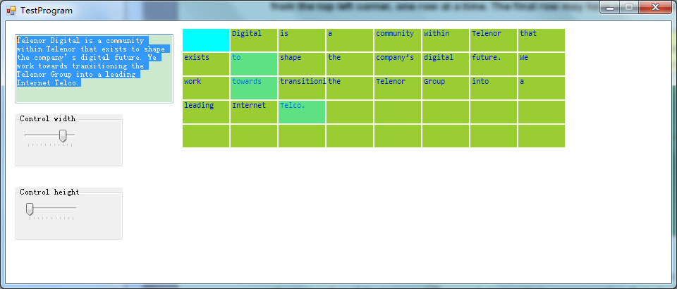
Fig. 1 The main GUI of TestProgram project

The requirements are broken down and implemented one by one.

Function 1: Present a big text input area in which a reasonably large text can be written or pasted.

I first developed a WinForm application named ”TestProgram” in Visual studio. It generated a windows form and I named it ”Form_ Main”. I added a ”textBox” component provided by Visual Studio 2010 toolbox to ”Form_ Main”. To test function 1, I use manual test.

The manual test results are:
Test Cases | Step Description | Expected Result | Actual Result (Pass/Fail)
TC1 | Invoke application from desktop icon. Input 1 single word to the big text input area. | Users should be presented with a text input area where this word can be written | Pass
TC2 | Invoke application from desktop icon. Input 20 words to the big text input area. | Users should be presented with a text input area where these 20 words can be written | Pass
TC3 | Invoke application from desktop icon. Input 101 words to the big text input area. | Users should be presented with a text input area where these 101 words can be written | Pass
TC4 | Invoke application from desktop icon. Paste 1 single word to the big text input area. | Users should be presented with a text input area where this word can be pasted | Pass
TC5 | Invoke application from desktop icon. Paste 20 words to the big text input area. | Users should be presented with a text input area where these 20 words can be pasted | Pass
TC6 | Invoke application from desktop icon. Paste 101 words to the big text input area. | Users should be presented with a text input area where these 101 words can be pasted. | Pass

Function 2: Present a slider control or similar which can be used to control the horizontal cell count (width) and height of the grid.

I added two ”trackBar” components provided by Visual Studio 2010 toolbox to ”Form_ Main”. I consider to define a range for the width (cell count) and height of the grid. The maximal value of width is 10, and the maximal value of height is also 10. The default grid size is width 5, height 5. To test function 2, I use manual test with the results are:

Test Cases | Step Description | Expected Result | Actual Result (Pass/Fail)
TC7 | Invoke application from desktop icon. Input some words. Use a slider bar to change the grid's width (horizontal cell count) to 6. | Users should observe that grids change from default widthxheight, 5x5 to 6x5. | Pass
TC8 | Invoke application from desktop icon. Input some words. Use a slider bar to change the grid's width (horizontal cell count) to 10. | Users should observe that grids change from default widthxheight, 5x5 to 10x5. | Pass
TC9 | Invoke application from desktop icon. Input some words. Use a slider bar to change the grid's width (horizontal cell count) to 0. | Users should observe that no grid is presented on the application form | Pass
TC10 | Invoke application from desktop icon. Input some words. Use a slider bar to change the grid's height (horizontal cell count) to 6. | Users should observe that grids change from default widthxheight, 5x5 to 5x6. | Pass
TC11 | Invoke application from desktop icon. Input some words. Use a slider bar to change the grid's height (horizontal cell count) to 10. | Users should observe that grids change from default widthxheight, 5x5 to 5x10. | Pass
TC12 | Invoke application from desktop icon. Input some words. Use a slider bar to change the grid's height (horizontal cell count) to 0. | Users should observe that no grid is presented on the application form | Pass

Function 3: Present a grid or table with cells contain the words from the text laid out from the top left corner, one row at a time. The final row may have to be padded.

I relied on capturing the Paint event of Form_Main. In order to implement function 3, I wrote a specific function to serve for grid view paint. It obtains the input texted and grid layout information, and displays the grid and texts on the right hand side of the Form_Main accordingly.
To test function 3, I use manual test with the results are:

Test Cases | Step Description | Expected Result | Actual Result (Pass/Fail)
TC13 | Invoke application from desktop icon. Input some words to the input area. | User should observe that the cells contain the words from the text laid out from the top left corner | Pass
TC14 | Invoke application from desktop icon. Input some words to the input area and then click "Enter", then input some other words | User should observe that the cells display the words input first time; after clicking "Enter", previous contents are cleared and new input texts are displayed | Pass

Function 4: The cost of moving from one cell (word) to another is equal to the absolute value of the integer difference between their corresponding first character codes (case insensitive). It is possible to move in 8 directions from each cell (except at the borders)

I wrote a specific function “Cost(string str1, string str2)” to calculate the cost of moving between neighbor cells. To test this function, I used unit test framework built in Visual Studio 2010.
[TestMethod]
public void NormalStringToValidateCost()
{
TestProgram _testProgram = new TestProgram();
string str1 = "fu";
string str2 = "chen";
int expected = 0;
if (!string.IsNullOrEmpty(str1) && !string.IsNullOrEmpty(str2))
{
byte[] asciiBytesStr1 = Encoding.ASCII.GetBytes(str1.ToUpper());
byte[] asciiBytesStr2 = Encoding.ASCII.GetBytes(str2.ToUpper());
expected = Math.Abs((int)(asciiBytesStr1[0]) - (int)(asciiBytesStr2[0]));
}
var actual = _testProgram.Cost(str1, str2);
Assert.AreEqual(expected, actual);
}
[TestMethod]
public void EmptyStringToValidateCost()
{
TestProgram _testProgram = new TestProgram();
string str1 = "";
string str2 = "";
int expected = 0;
var actual = _testProgram.Cost(str1, str2);
Assert.AreEqual(expected, actual);
}

For a certain cell location (sx, sy), it supports to move in 8 directions. I defined offset arrays to represent it.
int[] px = new int[] { 1, -1, 0, 0, 1, -1, 1, -1 }; // x axis offset
int[] py = new int[] { 0, 0, 1, -1, 1, 1, -1, -1 }; // y axis offset
I wrote a specific function “GridCost(int sx, int sy)” to calculate the cost of each cell. To test this function, I wrote a list of unit test considering edge and middle locations (here omit the details of unit test functions)
[TestMethod]
public void LeftUpperToValidateGridCost() //(sx,sy) is the left upper corner of the grid
[TestMethod]
public void RightUpperToValidateGridCost() //(sx,sy) is the right upper corner of the grid
[TestMethod]
public void LeftLowerToValidateGridCost() //(sx,sy) is the left lower corner of the grid
[TestMethod]
public void RightLowerToValidateGridCost() //(sx,sy) is the right lower corner of the grid
[TestMethod]
public void MiddleToValidateGridCost() //(sx,sy) is on the middle of the grid

The unit test results are as below:
Result | Test Name
Pass | NormalStringToValidateCost
Pass | EmptyStringToValidateCost
Pass | LeftUpperToValidateGridCost
Pass | RightUpperToValidateGridCost
Pass | LeftLowerToValidateGridCost
Pass | RightLowerToValidateGridCost
Pass | MiddleToValidateGridCost

Function 5: Highlight the cells which are on the path from the first word of the text to the last word, according to this scheme: it is possible to move in 8 directions from each cell (except at the borders), and the path should be optimal in terms of cost.
I implemented the Dijikstra’s algorithm to calculate the minimum distance between two points in the graph and to record the optimal path. The specific function is “GetShortedPath(int[,] G, int start, int end, int[] path)”
First, we use the manual test to verify function 5.
Test Cases | Step Description | Expected Result | Actual Result (Pass/Fail)
TC15 | Invoke application from desktop icon. Input some words to the input area. Calculate the cost of the highlighted path. | Users should observe the cells on the path are highlighted. It is possible to move in 8 directions from each cell (except at the borders). The path cost should be the optimal | Pass

For cross-validation, in the unit test we consider 2 scenarios given a defined adjacency matrix G:
- start != end
- start == end

Function 6: All view components should update in real time when the text or the slider value changes.
Test Cases | Step Description | Expected Result | Actual Result (Pass/Fail)
TC16 | Invoke application from desktop icon. Input some words to the big text input area. | Users should observe that the grid view updates in real time when the text changes. | Pass
TC17 | Invoke application from desktop icon. Use a slider bar to change the grid's width. | Users should observe that the grid view updates in real time when the slider value changes. | Pass

Compiling and Running Instructions
The compile and running procedures are:
- Double click to open the solution file: ”TestProgram.sln”. Then Visual Studio IDE (e.g. visual studio 2010 which is suggested) is started.
- To compile the project, users have multiple options. First press ”Build|Build Solution (F6)”, then choose ”Debug|Start menu (F5)” or ”Debug|Start without debugging (Ctrl+F5)”.
- Users can find .exe file in Windows Explorer .\TestProgram\TestProgram\bin\Debug. Invoke the .exe file by double clicking it.

